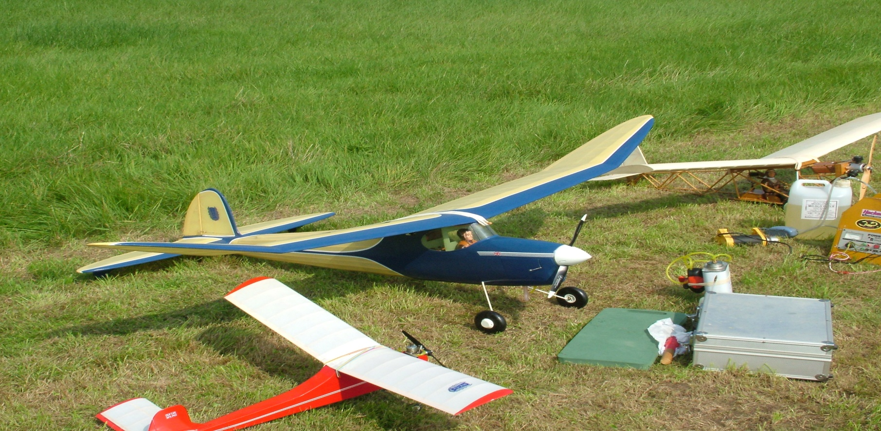
Eastbourne & District MFC
VINTAGE & CLASSIC Fly In 2018
Deanland Airfield, Ripe, East Sussex
Sunday 9th Sept. from 10am to 5pm
Dig out those old timers and classics and enjoy a relaxed days flying.
Bring along anyunwanted models and associated bits and pieces for an informal Bring & Buy
Pilot fee £5 and Proof of BMFA required
Further info from
Shaun Clay – shaun@saltwood35.co.uk
Tony Ding – bonding@sky.com
www.edmfc.co.uk

