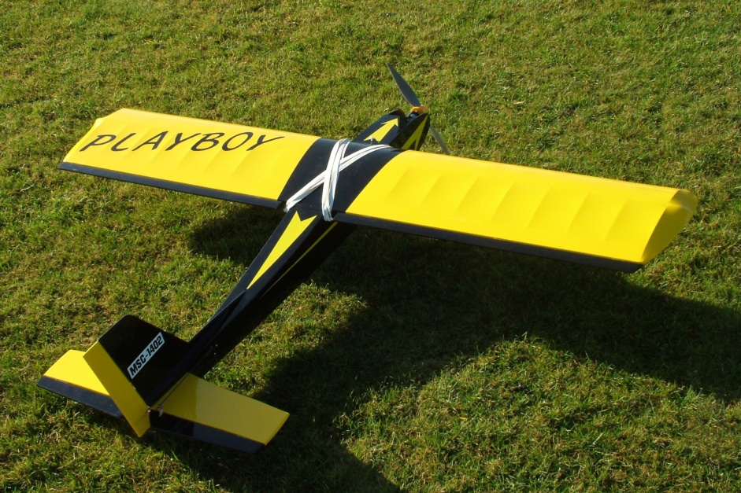
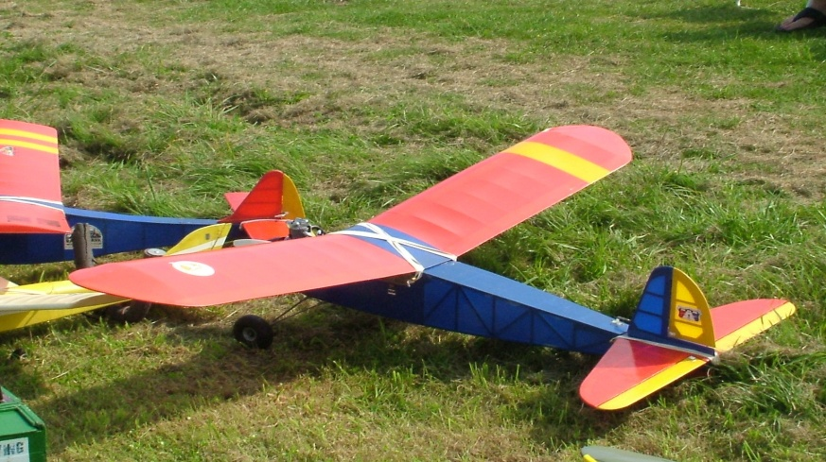
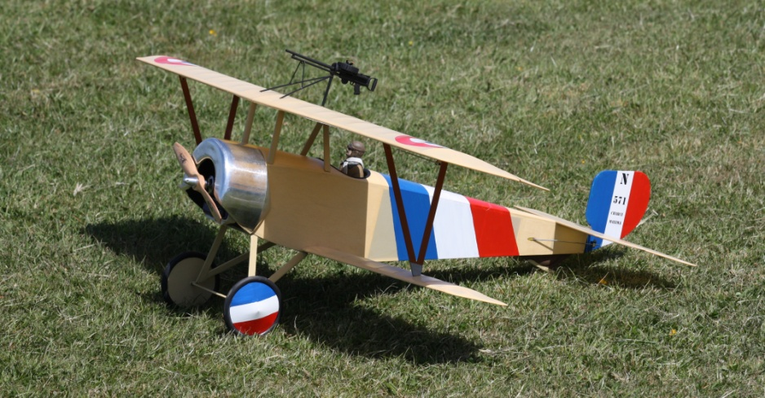
Eastbourne & District MFC
SCALE VINTAGE & CLASSIC
Fly In 2018
Deanland Airfield, Ripe, East Sussex
Sunday 24th June. from 10am to 5pm
A relaxed day of flying at this wonderful site.
Pilot fee £5 and Proof of BMFA required
Further info from
Shaun Clay – shaun@saltwood35.co.uk
Tony Ding – bonding@sky.com
www.edmfc.co.uk

